

PIPELINE ROW PATROL INSPECTION REPORT

**Targa Resources Northern Delaware**

**(RR GPX Lateral-2)**

June 2, 2025

**CONFIDENTIAL DOCUMENTS**

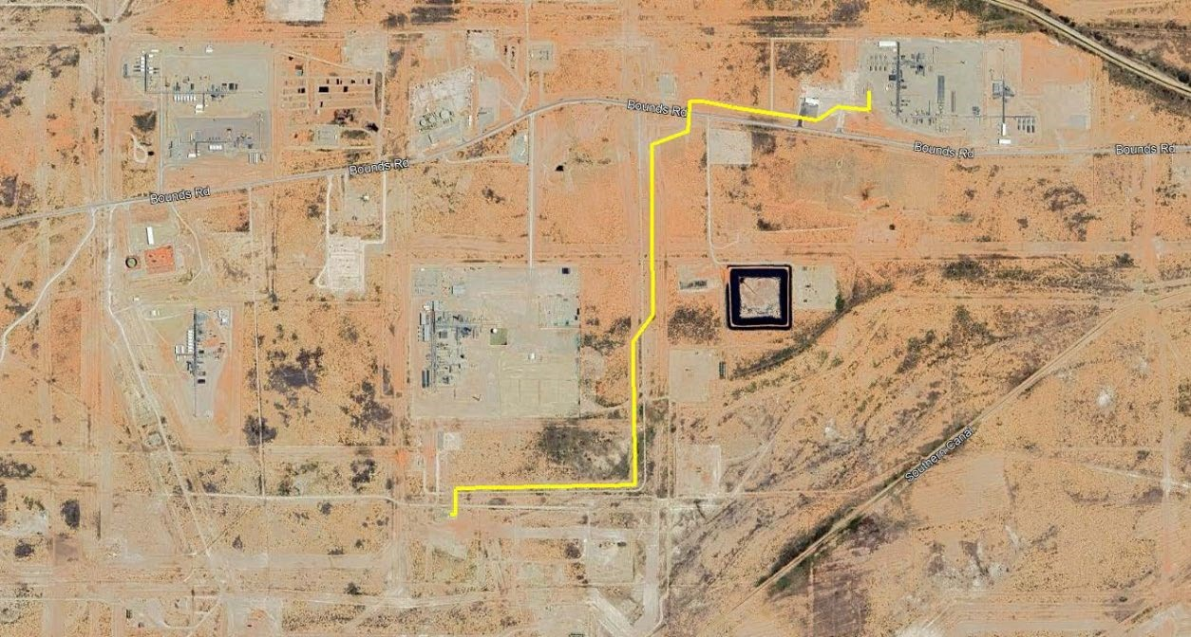

Arch Aerial, LLC

3701 Yale Street

Houston, TX 77018

281.974.5752